**CLASS DESIGN**

1. **Class “PaymentController”**

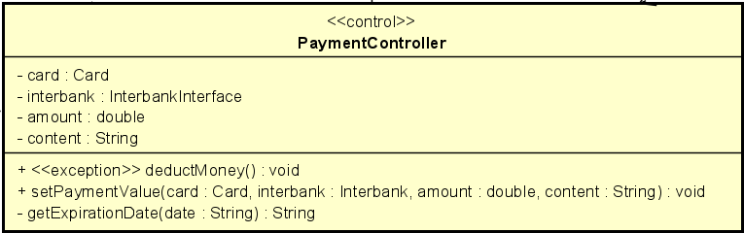

***Attribute***

|  |  |  |  |  |
| --- | --- | --- | --- | --- |
| # | Name | Data type | Default value | Description |
| 1 | card | Card | NULL | Represent the card used for payment |
| 2 | amount | double | NULL | Represent total amount of the transaction |
| 3 | content | String | NULL | Represent content of transaction |
| 4 | interbank | InterbankInterface | NULL | Represent the interbank |

***Operation***

|  |  |  |  |
| --- | --- | --- | --- |
| # | Name | Return type | Description (purpose) |
| 1 | deductMoney | void | Send request to interbank API to deduct money from card to pay for renting bike |
| 2 | setPaymentValue | void | Set value for all attributes of *PaymentController* class |

*Parameter*:

* card – the credit card used for payment
* interbank – interbank of transaction
* amount – total amount of transaction
* content – content of transaction

*Exception*:

* PaymentException: if responded with error that transaction is failed

***State*** None

***Method***

* getExpirationDate: given the String “date” representing the expiration date in the format “”mm/yy”, this method convert it into the required format “mmyy”. The algorithm is illustrated as follows.

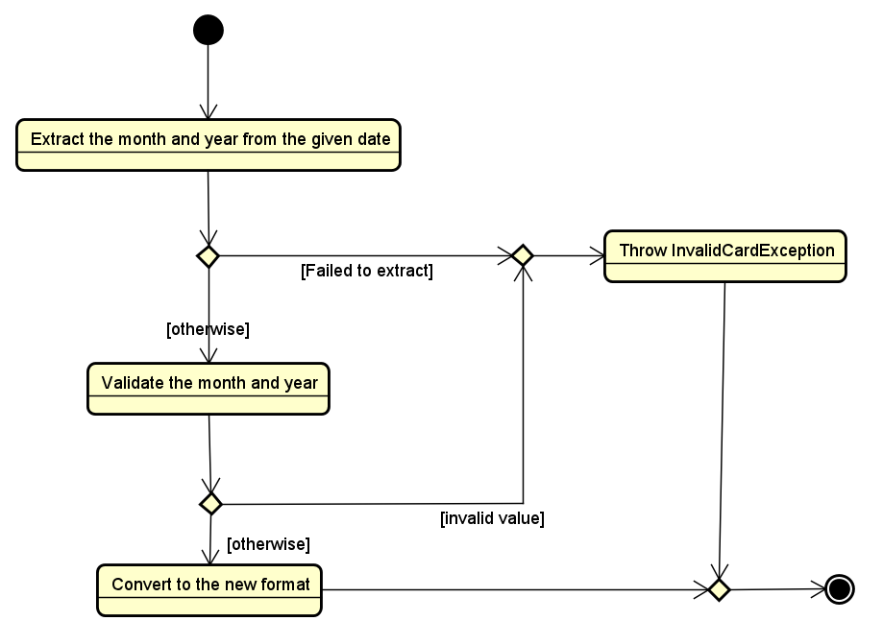

1. **Class “TransactionInfo”**

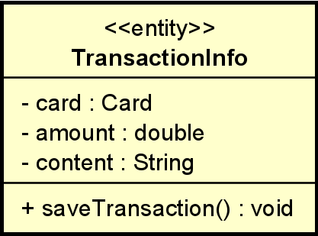

***Attribute***

|  |  |  |  |  |
| --- | --- | --- | --- | --- |
| # | Name | Data type | Default value | Description |
| 1 | card | Card | NULL | Represent the card used for payment |
| 2 | amount | double | NULL | Represent total amount of the transaction |
| 3 | content | String | NULL | Represent content of transaction |

***Operation***

|  |  |  |  |
| --- | --- | --- | --- |
| # | Name | Return type | Description (purpose) |
| 1 | saveTransaction | void | Save the transaction between software and interbank |

*Parameter*: None

*Exception*: None

***Method*** None

***State*** None

1. **Class “ReturnBikeController”**

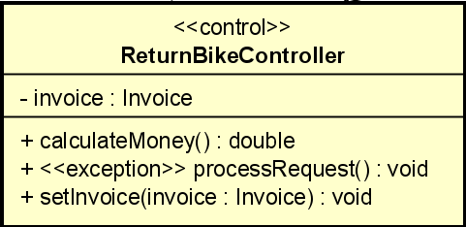

***Attribute***

|  |  |  |  |  |
| --- | --- | --- | --- | --- |
| # | Name | Data type | Default value | Description |
| 1 | invoice | Invoice | NULL | Represent invoice of returning bike |

***Operation***

|  |  |  |  |
| --- | --- | --- | --- |
| # | Name | Return type | Description (purpose) |
| 1 | calculateMoney | double | Calculate total amount that customer has to pay when return bike |
| 2 | processRequest | void | Process returning bike request, call *ReturnBikeHandler* and *InvoiceHandler* class |
| 3 | setInvoice | void | Set value for invoice after calculate money |

*Parameter*:

* Invoice – invoice of returning bike

*Exception*:

* ReturnBikeException: if responded with error that return bike request is failed

***State*** None

***Method*** None

1. **Class “RentedBikeInfoScreen”**

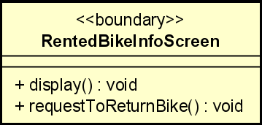

***Attribute***

***Operation***

|  |  |  |  |
| --- | --- | --- | --- |
| # | Name | Return type | Description (purpose) |
| 1 | display | void | Display detail of renting bike include amount up to now that customer has to pay |
| 2 | requestToReturnBike | void | Request to return bike |

*Parameter*: None

*Exception*: None

***Method*** None

***State*** None

1. **Class “PaymentHandler”**

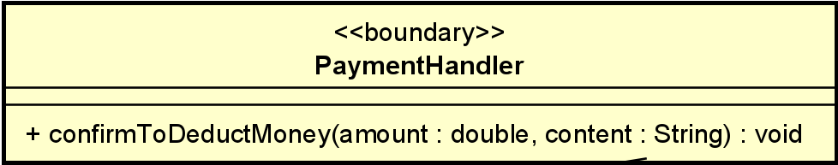

***Attribute***

***Operation***

|  |  |  |  |
| --- | --- | --- | --- |
| # | Name | Return type | Description (purpose) |
| 1 | confirmToDeductMoney | void | Confirm to deduct money from card to pay for renting bike |

*Parameter*:

* amount: total amount that interbank will deduct from customer’s card
* content: content of transaction

*Exception*: None

***Method*** None

***State*** None

1. **Class “InterbankInterface”**

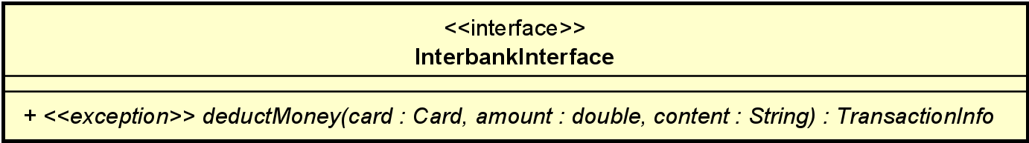

***Attribute***

***Operation***

|  |  |  |  |
| --- | --- | --- | --- |
| # | Name | Return type | Description (purpose) |
| 1 | deductMoney | void | Confirm to deduct money from card to pay for renting bike |

*Parameter*:

* amount: total amount that interbank will deduct from customer’s card
* content: content of transaction
* card : the credit card used for payment

*Exception*:

* InterbankPaymentException: if responded with a pre-defined error code
* UnrecognizeException: if responded with an unknown error code or something goes wrong

***Method*** None

***State*** None

1. **Class “ReturnBikeHandler”**

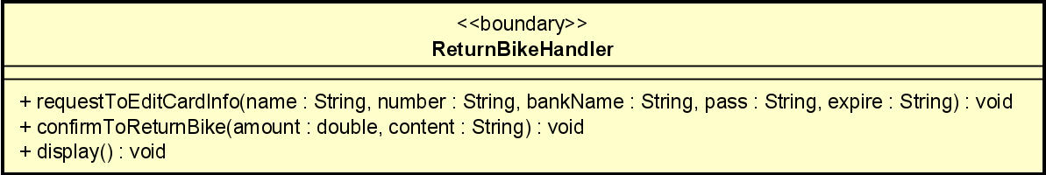

***Attribute***

***Operation***

|  |  |  |  |
| --- | --- | --- | --- |
| # | Name | Return type | Description (purpose) |
| 1 | requestToEditCardInfo | void | Edit card information |
| 2 | confirmToReturnBike | void | Confirm to return bike |
| 3 | display | void | Display detailed information of return bike and card information of customer |

*Parameter*:

* amount: total amount that customer has to pay for returning bike
* content: content of transaction
* name: card’s holder name
* number: card number
* bankName: name of interbank
* pass: security code of card
* expire: expiration date of card

*Exception*: None

***Method*** None

***State*** None

1. **Class “ListDockToReturnHandler”**

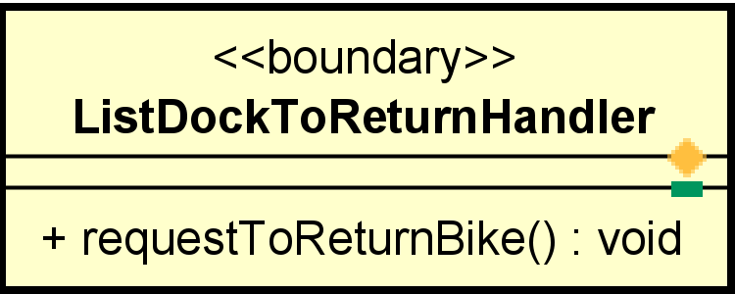

**Attribute**

**Operation**

|  |  |  |  |
| --- | --- | --- | --- |
| # | Name | Return type | Description (purpose) |
| 1 | requestToReturnBike | void | Request to return bike, call selectDockMakerController |

**Parameter**  none

**Method** none

**State** none

1. **Class “ViewBikeController”**

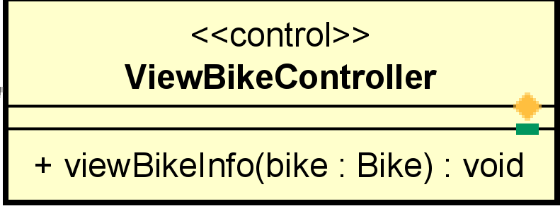

**Attribute** none

**Operation**

|  |  |  |  |
| --- | --- | --- | --- |
| # | Name | Return type | Description (purpose) |
| 1 | viewBikeInfo | void | Process request view specific bike info |

Parameter

* bike: bike that want to view information

Exception : ViewBikeException

**Method** none

**State** none

1. **Class “BikeInformationHandler”**

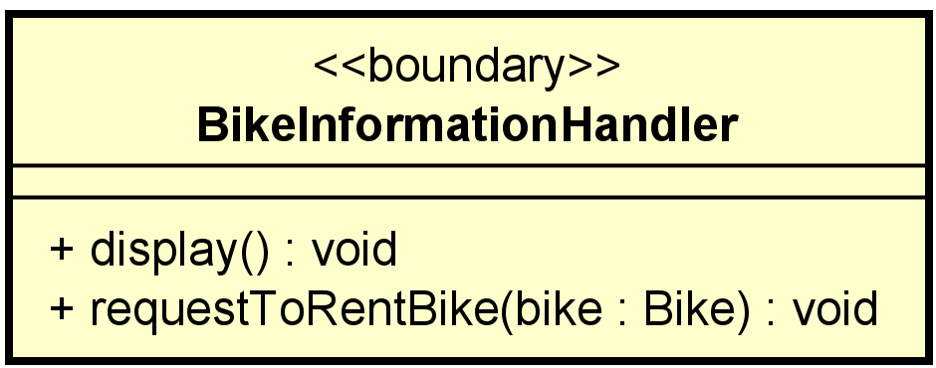

**Attribute** none

**Operation**

|  |  |  |  |
| --- | --- | --- | --- |
| # | Name | Return type | Description (purpose) |
| 1 | display | void | Display bike information |
| 2 | requestToRentBike | Void | When user submit to rent bike, sent request to rentBikeController |

Parameter

* bike: bike that user want to rent

**Method** none

**State** none

1. **Class “Bike”**

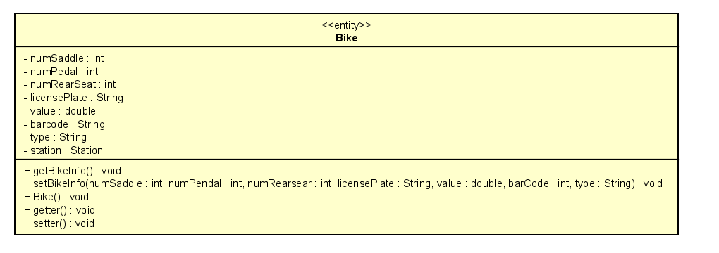

**Attribute**

|  |  |  |  |  |
| --- | --- | --- | --- | --- |
| # | Name | Data type | Default value | Description |
| 1 | id | Int | NULL | Id of the bike |
| 2 | numSaddle | int | NULL | Number saddle of the bike |
| 3 | numPedal | int | NULL | Number pedal of the bike |
| 4 | numRearSeat | Int | NULL | Number rear seat of the bike |
| 5 | licensePlate | String | NULL | Represent license plate of the bike |
| 6 | value | double | NULL | Represent value of the bike |
| 7 | barcode | String | NULL | Represent barcode of the bike |
| 8 | type | String | NULL | Represent type of the bike |
| 9 | station | Station | NULL | Represent bike in which station |

**Operation**

|  |  |  |  |
| --- | --- | --- | --- |
| # | Name | Return type | Description (purpose) |
| 2 | setBikeInfo | void | Set bike information |
| 3 | Bike | void | Constructor |
| 4 | getter | void | Get all attribute in acronym |
| 5 | setter | void | Set value for each attribute in acronym |

Parameter : same like attribute

**Method** none

**State**

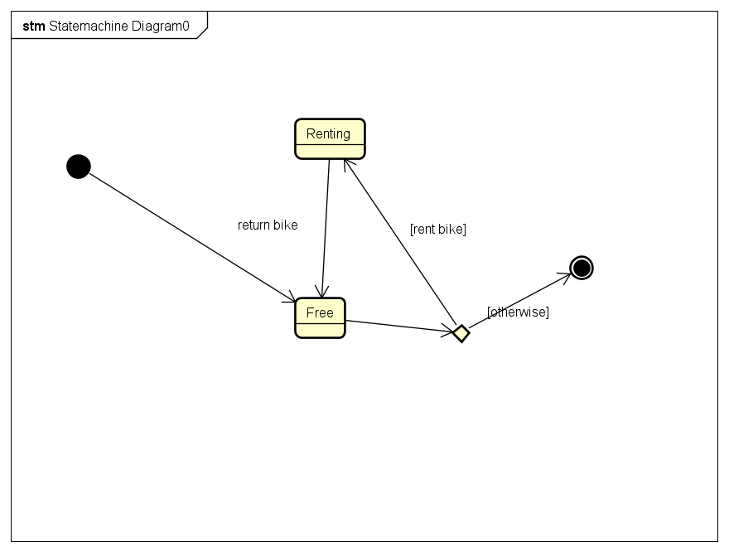

1. **Class “StandardElectricBike”**

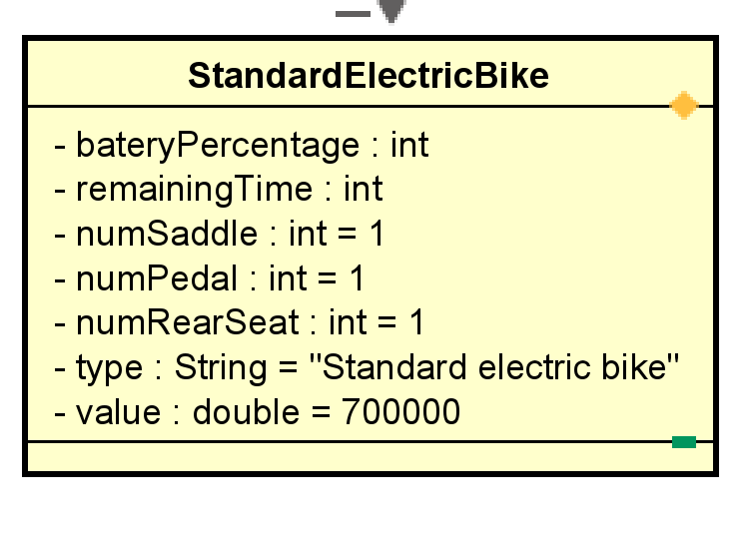

**Attribute**

|  |  |  |  |  |
| --- | --- | --- | --- | --- |
| # | Name | Data type | Default value | Description |
| 1 | numSaddle | int | 1 | Unchanged value |
| 2 | numPedal | int | 1 | Constant value |
| 3 | numRearSeat | int | 1 | Constant value |
| 4 | value | double | 700000 | Constant value |
| 5 | type | String | “Standard electric bike” | Constant type |
| 6 | batteryPercentage | Int | 100 | Constant value |
| 7 | remainingTime | Int | 14400 | Constant value(=4 hours) |

**Operation** inherit

**Method** none

**State** none

1. **Class “Standard bike”**

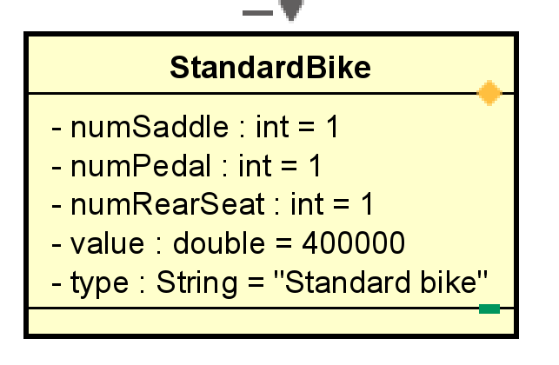

***Attribute***

|  |  |  |  |  |
| --- | --- | --- | --- | --- |
| # | Name | Data type | Default value | Description |
| 1 | numSaddle | int | 1 | Unchanged value |
| 2 | numPedal | int | 1 | Constant value |
| 3 | numRearSeat | int | 1 | Constant value |
| 4 | value | double | 400000 | Constant value |
| 5 | type | String | “Standard bike” | Constant type |

**Operation** inherit

**Method** none

**State** none

1. **Class “TwinBike”**

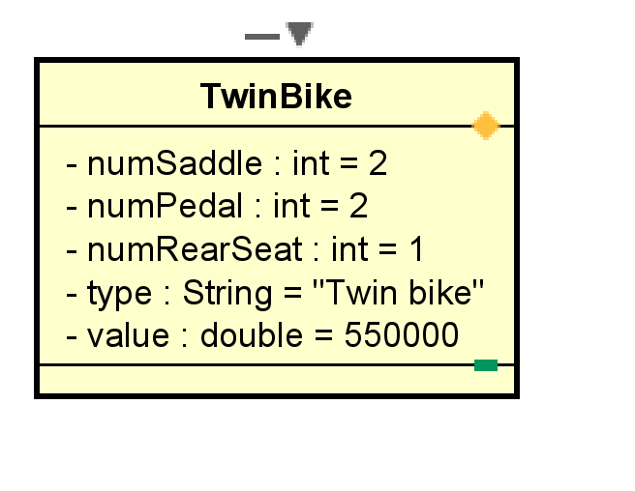

***Attribute***

|  |  |  |  |  |
| --- | --- | --- | --- | --- |
| # | Name | Data type | Default value | Description |
| 1 | numSaddle | int | 2 | Unchanged value |
| 2 | numPedal | int | 2 | Constant value |
| 3 | numRearSeat | int | 1 | Constant value |
| 4 | value | double | 550000 | Constant value |
| 5 | type | String | “Twin bike” | Constant type |

**Operation** inherit

**Method** none

**State** none

1. **Class “SelectDockMarkerController”**

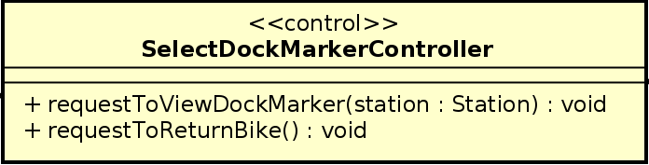

**Attribute** none

**Operation**

|  |  |  |  |
| --- | --- | --- | --- |
| # | Name | Return type | Description (purpose) |
| 1 | requestToViewDockMarker | void | Process request to view the dock marker |
| 2 | RequestToReturnBike | void | Process to request to return the bike |

Parameter

* station: station that want to view information

Exception : ViewStationException

**Method** none

**State** none

1. **Class “ViewStationController”**

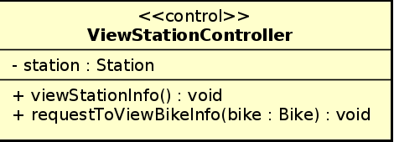

**Attribute** station: station that user want to view information

**Operation**

|  |  |  |  |
| --- | --- | --- | --- |
| # | Name | Return type | Description (purpose) |
| 1 | viewStationInfo | void | View station information |
| 2 | requestToViewBikeInfo | Void | Process to request to view bike information |

Parameter

* bike: bike that user want to rent

**Method** none

**State** none

1. **Class “ListDockForViewHandler”**

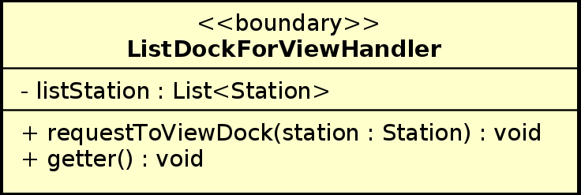

**Attribute** listStation: a list of stations

**Operation**

|  |  |  |  |
| --- | --- | --- | --- |
| # | Name | Return type | Description (purpose) |
| 1 | requestToViewDock | void | Process to request to view dock |
| 2 | getter | Void | get method |

Parameter

* station: station that user want to view information

**Method** none

**State** none

1. **Class “StationInfoHandler”**

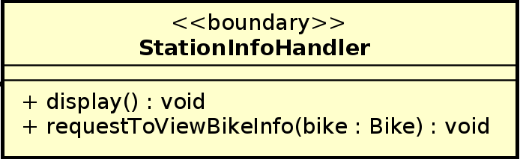

**Attribute** none

**Operation**

|  |  |  |  |
| --- | --- | --- | --- |
| # | Name | Return type | Description (purpose) |
| 1 | display | void | Display station information |
| 2 | requestToViewBikeInfo | Void | Process to request to view bike information |

Parameter

* bike: bike that user want to view information

**Method** none

**State** none

1. **Class “ListBikeHandler”**

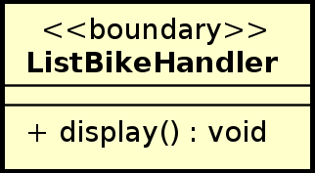

**Attribute** none

**Operation**

|  |  |  |  |
| --- | --- | --- | --- |
| # | Name | Return type | Description (purpose) |
| 1 | display | void | Display list of bikes |

Parameter none

**Method** none

**State** none

1. **Class “Station”**

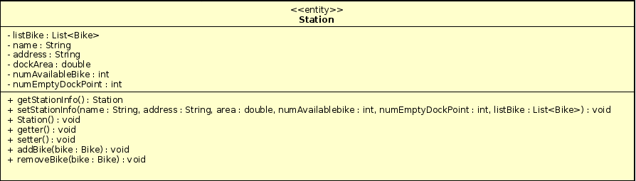

**Attribute**

|  |  |  |  |  |
| --- | --- | --- | --- | --- |
| # | Name | Data type | Default value | Description |
| 1 | listBike | List<Bike> | NULL | List the bikes in the station |
| 2 | name | String | NULL | Name of the station |
| 3 | address | String | NULL | Address of the station |
| 4 | dockArea | double | NULL | Area of the dock |
| 5 | numAvailableBike | int | NULL | Number of available bikes |
| 6 | numEmptyDockPoint | int | NULL | Number of empty dock points |

**Operation**

|  |  |  |  |
| --- | --- | --- | --- |
| # | Name | Return type | Description (purpose) |
| 1 | getStationInfo | Station | Get station information for display |
| 2 | setStationInfo | void | Set station information |
| 3 | Station | void | Constructor |
| 4 | getter | void | Get all attribute in acronym |
| 5 | setter | void | Set value for each attribute in acronym |
| 6 | addBike | void | Add bike to the station if user return bike |
| 7 | removeBike | void | Remove bike in the station if user rent bike |

Parameter : same like attribute

**Method** none

**State** none

1. **Class “Card”**

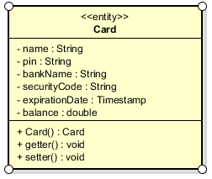

***Attribute***

|  |  |  |  |  |
| --- | --- | --- | --- | --- |
| # | Name | Data type | Default value | Description |
| 1 | name | String | NULL | Name of the owner of the credit card |
| 2 | pin | String | NULL | Pin code of the credit card |
| 3 | bankName | String | NULL | The name of the bank that provides the credit card |
| 4 | securityCode | String | NULL | Security code of the credit card |
| 5 | expirationDate | Timestamp | NULL | The expiration date of the card, in form MM/YYYY |
| 6 | Balance | double | 0.00 | The balance of the card |

***Operation***

|  |  |  |  |
| --- | --- | --- | --- |
| # | Name | Return type | Description (purpose) |
| 1 | Card | Card | Constructor |
| 2 | getter | void | Get all attribute in acronym |
| 3 | setter | void | Set value for each attribute in acronym |

Parameter: same as attributes

***State***

None

***Method***

None

1. **Class “InvoiceHandler”**

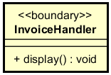

***Attribute***

None

***Operation***

|  |  |  |  |
| --- | --- | --- | --- |
| # | Name | Return type | Description (purpose) |
| 1 | display | void | Display the invoice screen |

***State***

None

***Method***

None

1. **Class “Invoice”**

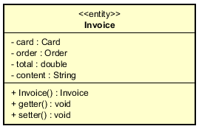

***Attribute***

|  |  |  |  |  |
| --- | --- | --- | --- | --- |
| # | Name | Data type | Default value | Description |
| 1 | card | Card | NULL | The credit card that was used for this transaction/invoice |
| 2 | order | Order | NULL | The order that was used for this transaction/invoice |
| 3 | total | double | 0.00 | The amount of money that was transferred in the transaction/The amount of money that was deducted from the credit card in the transaction |
| 4 | content | String | NULL | The details of the transaction/invoice |

***Operation***

|  |  |  |  |
| --- | --- | --- | --- |
| # | Name | Return type | Description (purpose) |
| 1 | Invoice | Invoice | Constructor |
| 2 | getter | void | Get all attribute in acronym |
| 3 | setter | void | Set value for each attribute in acronym |

Parameter: same as attributes

***State***

None

***Method***

None

1. **Class “Order”**

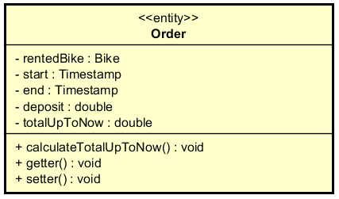

***Attribute***

|  |  |  |  |  |
| --- | --- | --- | --- | --- |
| # | Name | Data type | Default value | Description |
| 1 | rentedBike | Bike | NULL | The bike that was rented by user |
| 2 | start | Timestamp | Time when the bike was rented | The timestamp which user rented the bike |
| 3 | end | Timestamp | Current Time | The timestamp which user returns bike (in case this order is for returning bike), or current time (in case this order is for renting bike) |
| 4 | deposit | double | 0.00 | The deposit when renting the bike |
| 5 | totalUpToNow | double | 0.00 | Total renting money up to now (not include deposit) |

***Operation***

|  |  |  |  |
| --- | --- | --- | --- |
| # | Name | Return type | Description (purpose) |
| 1 | calculateTotalUpToNow | void | Calculate the renting amount up to now (not include deposit) |
| 2 | getter | void | Get all attribute in acronym |
| 3 | setter | void | Set value for each attribute in acronym |

Parameter: same as attributes

***State***

None

***Method***

None

1. **Class “RentBikeController”**

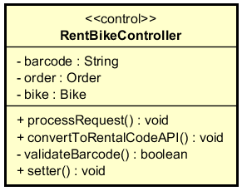

***Attribute***

|  |  |  |  |  |
| --- | --- | --- | --- | --- |
| # | Name | Data type | Default value | Description |
| 1 | barcode | String | NULL | The barcode of the rented bike |
| 2 | order | Order | NULL | The order is made when renting bike |
| 3 | bike | Bike | NULL | The rented bike |

***Operation***

|  |  |  |  |
| --- | --- | --- | --- |
| # | Name | Return type | Description (purpose) |
| 1 | processRequest | void | Process the request of renting bike, to see that if the request comes from user entering the barcode or user choosing the bike |
| 2 | validateBarcode | boolean | In case the user entering the barcode (the barcode attribute is not empty), then we should check if the barcode is valid. If it is, call the setter of the bike attribute. If it is not, an error is displayed in the barcode screen. |
| 3 | convertToRentalCodeAPI | void | Call the API to convert the barcode into rental code |
| 4 | setter | void | Set value for each attribute in acronym |

Parameter:

None

Exception:

* RentBikeException: if responded with error that rent bike request is failed

***State***

None

***Method***

None

1. **Class “RentBikeHandler”**

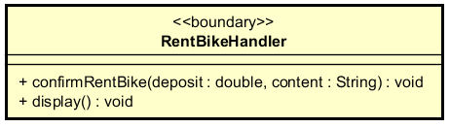

***Attribute***

None

***Operation***

|  |  |  |  |
| --- | --- | --- | --- |
| # | Name | Return type | Description (purpose) |
| 1 | display | void | Display the rent bike screen |
| 2 | confirmRentBike | void | Display the payment screen, send the deposit amount and the transaction content to the payment controller |

Parameter:

* deposit - the deposit amount that user has to pay when renting bike
* content - the details of the transaction when sending to payment

***State***

None

***Method***

None

1. **Class “BarcodeHandler”**

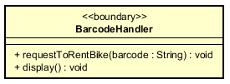

***Attribute***

None

***Operation***

|  |  |  |  |
| --- | --- | --- | --- |
| # | Name | Return type | Description (purpose) |
| 1 | display | void | Display the barcode screen |
| 2 | requestToRentBike | void | After the user inputs the barcode, this function sends the barcode to controller to process the rent-bike request |

Parameter:

* barcode: the code that user inputs when he/she wants to rent bike

***State***

None

***Method***

None